Geraldton Senior High School
ATMAM Math Methods
Test 1: Chapters 1 to 5

20 minutes Section 1 - Calculator Free 20 marks
SOLUTIONS

- [6 marks]
A body moves under rectilinear motion such that for time $t$seconds, $0≤t≤5$, the body’s displacement, $x$metres, from the origin O is given by
$$x\left(t\right)=t^{3}-9t^{2}+24t$$

  - Determine its acceleration at $t=10$. (2 mark)
Solution | Specific Behaviours
$$\begin{aligned}v\left(t\right)=\frac{d}{dt}\left(x(t)\right)=&3x^{2}-18t+24 \\ a\left(t\right)=\frac{d}{dt}\left(v\left(t\right)\right)=&6x-18 \\ \\ a\left(10\right)=&6\left(10\right)-18 \\ =&60-18 \\ =&42 \\ \\ ∴Accel. is 10m/s^{2}\end{aligned}$$ | - Uses first derivative to determine velocity.  - Uses second derivative to determine acceleration and evaluates at $t=10$.

  - Use calculus techniques and the second derivative to determine and justify when the displacement is at a maximum.
(4 marks)
Solution | Specific Behaviours
$$\begin{aligned}Max Disp⟹&x^{'}(t)=0 \\ ⟹&v\left(t\right)=0 \\ ⟹&3x^{2}-18t+24=0 \\ ⟹&x^{2}-6t+8=0 \\ ⟹&\left(x-2\right)\left(x-4\right)=0 \\ &x=2, x=4 \\ \\ Max ⟹&x^{'}'(t)=0 \\ ⟹&a(t)<0 \\ \\ a\left(t\right)=&6x-18 \\ a\left(4\right)>&0 \\ a\left(2\right)<&0⟹Max displ. at x=2 \\ \\ x(2)=&2^{3}-9\left(2^{2}\right)+24(2)& \\ =&8-36+48=20 \\ \\ ∴Max disp. is 20m\end{aligned}$$ | - Recognizes that max displacement occurs when $v\left(t\right)=0$ and determines $v(t)$ .  - Solves $v\left(t\right)=0$.  - Determines $a\left(t\right)$ and uses Second Derivative Test to identify max. at $x=2$.  - Substitutes $x=2$ into $x(t)$ to determine maximum displacement.
- [5 marks]
For the following questions, do not simplify your answers.
  - Determine (3 marks)
$$\frac{d}{dx}\left(\frac{\sqrt{x}}{1-x^{2}}\right)\begin{matrix}→u \\ →v\end{matrix}$$

Solution | Specific Behaviours
$$\begin{aligned}\frac{d}{dx}\left(\frac{\sqrt{x}}{1-x^{2}}\right)=&\frac{u^{'}v-uv'}{v^{2}} \\ =&\frac{\frac{1}{2\sqrt{x}}\left(1-x^{2}\right)-\sqrt{x}(-2x)}{{\left(1-x^{2}\right)}^{2}}\end{aligned}$$ | - Determines $u^{'}v$  - Determines $uv'$  - Uses Quotient Rule correctly and divides by $v^{2}$

  - Determine $f^{'}\left(x\right)$ given that (2 marks)
$$f\left(x\right)=\begin{matrix}\left(1-2\sqrt{x}\right) \\ u\end{matrix}\begin{matrix}\left(\sqrt{x}+x+1\right) \\ v\end{matrix}$$
Solution | Specific Behaviours
$$\begin{aligned}f^{'}\left(x\right)=&u^{'}v+uv' \\ =&\frac{2}{2\sqrt{x}}\left(\sqrt{x}+x+1\right)+\left(1-2\sqrt{x}\right)\left(\frac{1}{2\sqrt{x}}+1\right)\end{aligned}$$ | - Determines $u^{'}v$  - Determines $uv'$ using the Product Rule correctly.

- [5 marks]
Determine
  - $\int{\frac{1-x}{\sqrt{x}}}dx$ (2 marks)
Solution | Specific Behaviours
$$\begin{aligned}∫\frac{1-x}{\sqrt{x}}dx=&∫\frac{1}{\sqrt{x}}-\frac{x}{\sqrt{x}}dx \\ =& 2\sqrt{x}-\frac{2}{3}\sqrt{x^{3}}+c \\ =&2x^{\frac{1}{2}}-\frac{2}{3}x^{\frac{3}{2}}+c\end{aligned}$$ | - Writes the integrand as two separate fractions for purposes of integrating.  - Uses the additivity of integration to correctly integrate.

  - $\int_{-1}^{1}{\begin{matrix} \\ {\left(3x-1\right)}^{2} \\ \end{matrix}}dx$ (3 mark)

Solution | Specific Behaviours
$$\begin{aligned}\int_{-1}^{1}{\begin{aligned} \\ {\left(3x-1\right)}^{2} \\ \end{aligned}}=&{\left[\frac{{\left(3x-5\right)}^{3}}{9}+c\right]}_{-1}^{1}&& \\ =&\frac{1}{9}\left[{\left(3\left(1\right)-1\right)}^{3}-{\left(3\left(-1\right)-1\right)}^{3}\right] \\ =&\frac{1}{9}\left(8-{\left(-4\right)}^{3}\right)=\frac{1}{9}\left(8+64\right) \\ =&\frac{72}{9}=8\end{aligned}$$ | - Uses understanding of chain rule to obtain correct integral.  - Substitutes the given bounds correctly as per FTC part 2.  - Correctly evaluates the definite integral.

- [4 marks]
Consider the functions given by $y=t^{3}-4t$ and $t=\sqrt{x+1}$ .
Determine:

  - $\frac{dy}{dt}$ (1 mark)

Solution | Specific Behaviours
$$\begin{aligned}\frac{dy}{dt}=3t^{2}-4t \\ \end{aligned}$$ | - Determines $\frac{dy}{dt}$

  - $\frac{dt}{dx}$ (1 mark)

Solution | Specific Behaviours
$$\begin{aligned}\frac{dt}{dx}=\frac{1}{2\sqrt{x+1}} \\ \end{aligned}$$ | - Uses the chain rule (short form) to determine $\frac{dt}{dx}$

And hence,
  - Use parts a) and b) to determine $\frac{dy}{dx}$ in its simplest form. (2 marks)

Solution | Specific Behaviours
$$\begin{aligned}\frac{dy}{dx}=&\frac{dy}{dt}×\frac{dt}{dx} \\ =&(3t^{2}-4t)\frac{1}{2\sqrt{x+1}} \\ =&\frac{3{\left(\sqrt{x+1}\right)}^{2}}{2\sqrt{x+1}}-\frac{4\sqrt{x+1}}{2\sqrt{x+1}}& \\ =&\frac{3}{2}\sqrt{x+1}-2\end{aligned}$$ | - Uses chain rule in long form to express  $\frac{dy}{dx}=\frac{dy}{dt}×\frac{dt}{dx}$  - Correctly simplifies the product.

NAME: TEACHER:
Geraldton Senior High School
ATMAM Math Methods
Test 1: Chapters 1 to 5

35 minutes Section 2 - Calculator Assumed 35 marks

- [4 marks]
A sphere of radius 30 cm is sitting on the base of a container of water. The water level is rising at a rate of 2 cm per second, so that the sphere is gradually becoming submerged.

Let h be the height of the water as illustrated below left. The submerged portion of the sphere is as shown below right.

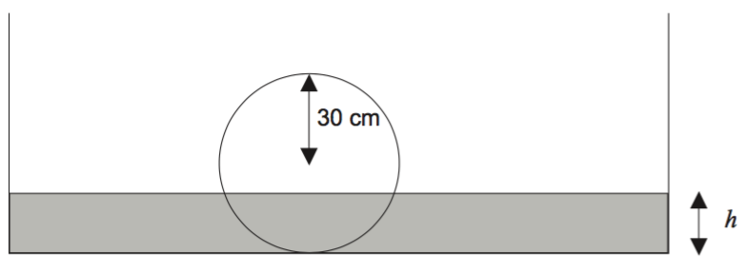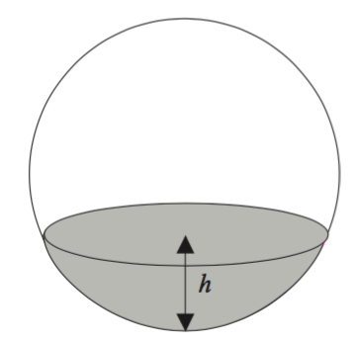
The volume of the submerged portion, where $r$is the radius of the sphere is given by
$$V=\frac{πh^{2}}{3}\left(3r-h\right), 0≤h≤2r$$
Using the small change formula: $δV≈\frac{dV}{dh}δh$ or equivalently $δV≈V^{'}\left(h\right)×δh$

Calculate to 1d.p. the approximate increase in submerged volume for a $0.1cm$ increase in height when $h=15cm$

Solution | Specific Behaviours
$$\begin{aligned}&\frac{dV}{dh}=-π\left(h^{2}-2rh\right) CAScalc \\ where r=30cm, h=15cm \\ \\ &δh=0.1 \\ \\ \\ δV≈&-π\left({15}^{2}-2\left(30\right)\left(15\right)\right)×0.1 \\ ≈&\frac{135π}{2} \\ ≈&212.1 \\ \\ \\ ∴&Submerged vol icreases by≈212cm^{3}&\end{aligned}$$ | - Determines $\frac{dv}{dh}$ (with or without initially substituting $h=15$  - States $δh=0.1$  - Correctly applies the incremental change formula.  - Correctly evaluates substituted values.

- [6 marks]
The graph of the function $y=f(x)$ is shown below over the domain $-2≤x≤2$.
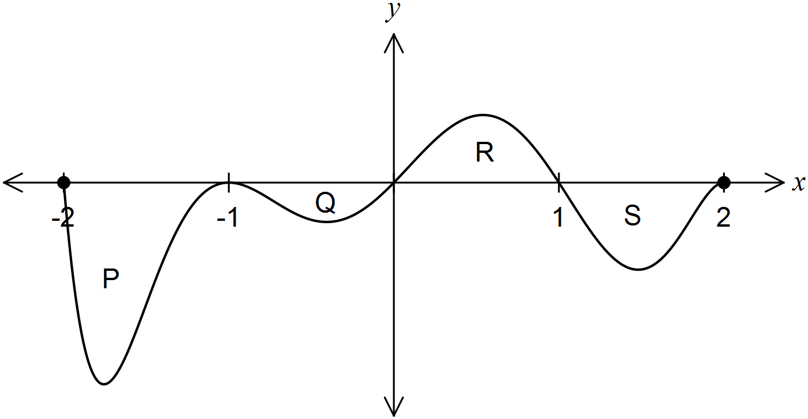
The areas of regions P, Q, R and S enclosed by the curve and the $x-axis$ are 5, 1, 2 and 3 square units respectively.

  - Determine the area enclosed by the curve and the $x-axis$ for $-1≤x≤1$. (1 mark)
Solution | Specific Behaviours
$$Area=1+2=3{\left(units\right)}^{2}$$ | - Correctly sums the indicated areas.

  - Determine the value of

- $\int_{-1}^{2}{\begin{matrix} \\ f(x) \\ \end{matrix} dx}$ $=-1+2+\left(-3\right)=-2$ (1 mark)

Solution | Specific Behaviours
$=-1+2+\left(-3\right)=-2$ | - Correctly sums the signed areas to obtain the definite integral.

- $\int_{0}^{2}{\begin{matrix} \\ f\left(x-1\right) \\ \end{matrix}dx}$ (2 marks)

Solution | Specific Behaviours
$=\int_{-1}^{1}{\begin{aligned} \\ f\left(x\right) \\ \end{aligned}}dx=-1+2=1$ | - Recognises a horizontal translation at play  - Sums the signed areas to obtain the Definite Integral

- $\int_{-1}^{2}{\begin{matrix} \\ 2x+f\left(x\right) \\ \end{matrix} dx}$ (2 marks)

Solution | Specific Behaviours
$$\begin{aligned}=&\int_{-1}^{2}{\begin{aligned} \\ 2x \\ \end{aligned}} dx+\int_{-1}^{2}{\begin{aligned} \\ f(x) \\ \end{aligned}}&&&dx \\ =&{\left[\begin{aligned} \\ x^{2}+c \\ \end{aligned}\right]}_{-1}^{2}+(-2) \\ =&{\left(2\right)}^{2}-{\left(-1\right)}^{2}-2=1\end{aligned}$$ | - Uses additivity of integration to separate the integral.  - Uses the result from part i) and the definite integral $\int_{-1}^{2}{\begin{aligned} \\ 2x \\ \end{aligned}} dx$ to obtain the final result.

- [7 marks]

A cylinder of radius $r$metres and height $h$ metres is to be constructed inside a cone of height $6 metres$ and base radius $3 metres$ as shown.
  - Show clearly why $h = 6 2r$. (1 mark)
6
6–h
r
3
h
Solution | Specific Behaviours
$$\begin{aligned}Construct contains similar \\ triangles s.t. \\ \frac{r}{3}=\frac{6-h}{6} \\ i.e.\frac{6r}{3}=6-h \\ i.e.2r=6-h \\ ∴h=&6-2r\end{aligned}$$ | - Uses similar triangles to obtain the ratio $\frac{r}{3}=\frac{6-h}{6}$ and isolates $h$

  - Show clearly why the volume of the cylinder is given as: $V=6πr^{2}-2πr^{3}$ (2 marks)

Solution | Specific Behaviours
$$\begin{aligned}V\left(cylinder\right)=&πr^{2}h \\ =&πr^{2}\left(6-2r\right) \\ =&6πr^{2}-2πr^{3}\end{aligned}$$ | - Substitutes $h=6-2r$ into $πr^{2}h$  - Expands and simplifies to obtain correct formula

  - Use calculus to determine the dimensions (i.e. height & radius) of such a cylinder which gives maximum volume. (4 marks)

Solution | Specific Behaviours
$$\begin{aligned}Volume maximised& at\frac{dV}{dr}=0 \\ \frac{dV}{dr}=&6πr^{2}+12πr \\ \frac{dV}{dr}=&0⟹r=0, r=2 \\ & r=0 not viable \\ \\ \frac{d^{2}V}{dr^{2}}=&-12πr+12π \\ {\left.\frac{d^{2}V}{dr^{2}}\right|}_{r=2}=&-12π<0⟹Max \\ \\ r=2⟹h=&6-2\left(2\right) \\ =&2 \\ \\ ∴Volume maximised with r=2m and h=2m\end{aligned}$$ | - Recognizes that volume is maximised at $\frac{dV}{dr}=0$ and determines $\frac{dV}{dr}$  - Solves $\frac{dV}{dr}=0$  - Uses the Second Derivative to justify that a maximum is obtained at $r=2$  - Substitutes into $h=6-2r$ to determine correct dimensions.

- [8 marks]
A particle, initially stationary and at the origin, moves subject to an acceleration, $a$ ms⁻², as shown in the graph below for $0≤t≤20$ seconds.
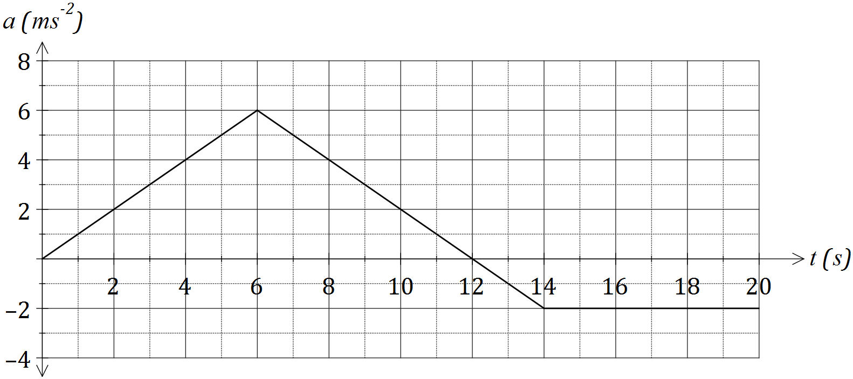
(a) Determine the velocity of the object when

- $t=6$. (1 mark)
Solution | Specific Behaviours
$$\begin{aligned}initially &stationary at origin⟹v\left(0\right)=0 \\ and x\left(0\right)=0 \\ \\ v\left(6\right)=&Δv from t=0 to t=6 \left(i.e. Δv+0\right) \\ =&\int{\frac{dv}{dt}}dt=\int_{0}^{6}{a\left(t\right)}dt+0=Area+0 \\ =&\frac{1}{2}\left(6\right)\left(6\right)=18 \\ \\ ∴vel. is 18m/s&\end{aligned}$$ | - Identifies $v\left(6\right)=Δv (change in v)$ using initial conditions and area to determine velocity

- $t=20$. (2 marks)
Solution | Specific Behaviours
$$\begin{aligned}v\left(20\right)=&Δv\left|{20 \atop 0}\right.+0 \\ =&\int_{0}^{20}{a\left(t\right)}dt=\sum{signed areas} \\ =&36-2-12 \\ =&22 \\ \\ ∴vel. is 22 m/s&\end{aligned}$$ | - Identifies $v\left(20\right)=Δv$ using initial conditions  - Sums signed areas to determine velocity

(b) At what time is the velocity of the body a maximum, and what is the maximum velocity?
(2 marks)
Solution | Specific Behaviours
$$\begin{aligned}Max vel.⟹&a\left(t\right)=0 \\ ⟹&t=12 \\ \\ Max vel.=&Δv\left|{12 \atop 0}\right.+0 \\ =&\int_{0}^{12}{a\left(t\right)}dt=Area \\ =&36 \\ \\ ∴Max vel. is 36& m/s&\end{aligned}$$ | - Identifies maximum velocity at $a\left(t\right)=0$  - Determines area to calculate maximum velocity

(c) Determine the distance of the particle from the origin after $3$ seconds. (3 marks)
Solution | Specific Behaviours
$$\begin{aligned}At t=3, a\left(t\right)=&t \\ v\left(t\right)=&\int{t}dt \\ =&\frac{t^{2}}{2}+c \\ v\left(0\right)=0⟹c=&0 so v\left(t\right)=\frac{t^{2}}{2} \\ x\left(t\right)=&\int{\frac{t^{2}}{2}}dt \\ =&\frac{t^{3}}{6}+c \\ x\left(0\right)=0⟹c=&0, so x\left(t\right)=\frac{t^{3}}{6} \\ x\left(3\right)=&\frac{3^{3}}{6}=\frac{9}{2} \\ ∴disp. at t=3 is 4.5m&\end{aligned}$$ | - Integrates $a\left(t\right)$ using initial conditions to determine $v(t)$  - Integrates $v(t)$ using initial conditions to determine $x(t)$  - Evaluates $x(t)$ at $t=3$ to determine displacement.

- [5 marks]
Leveraging your calculator use the calculus tools of the first and second derivative to determine the location and nature of all the stationary points of
$$y={\left(x-1\right)}^{3}{\left(x-4\right)}^{2}$$
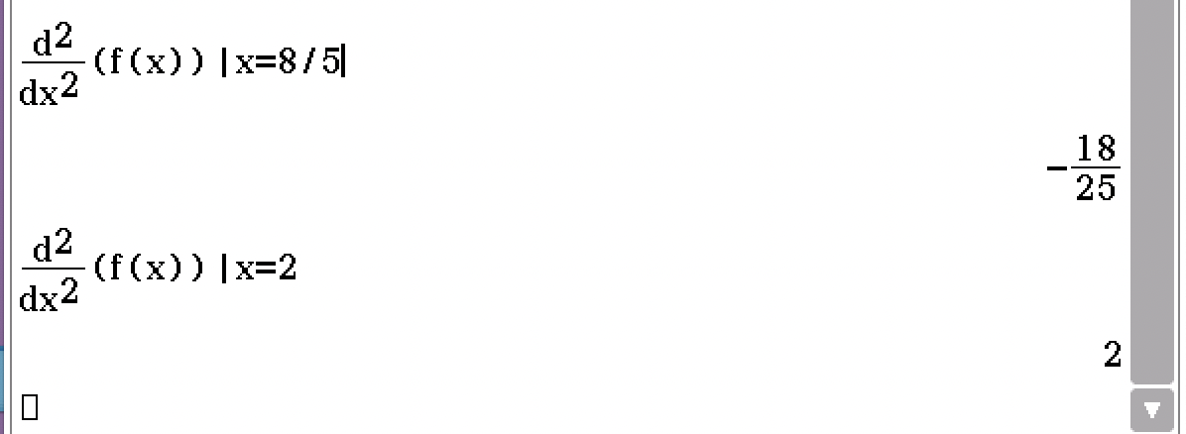
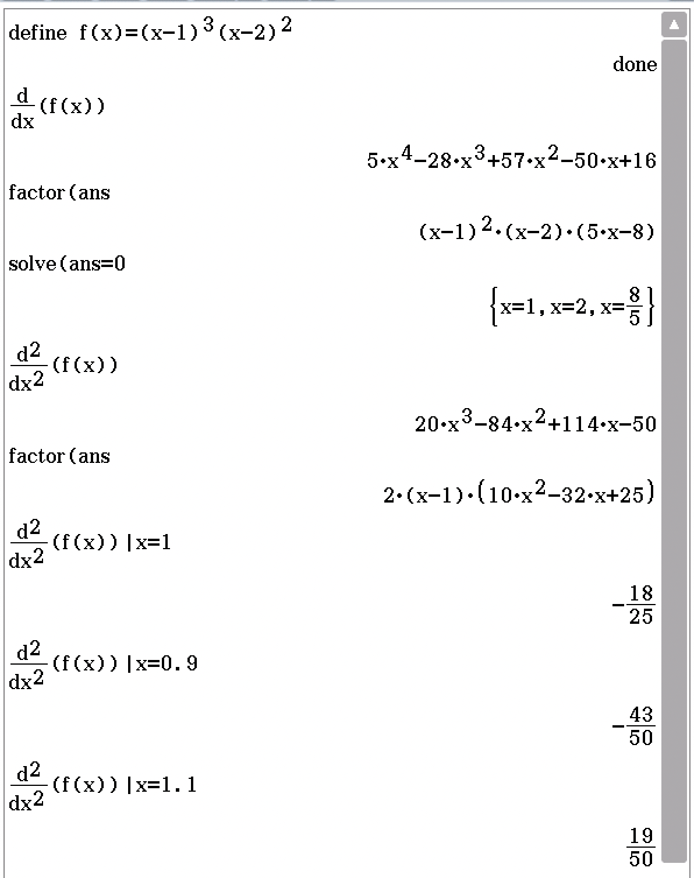
✓
✓
✓
✓
✓
$$\begin{aligned}Stn Pnts⟹\frac{dy}{dx}=&0 \\ \frac{dy}{dx}=&5x^{4}-28x^{3}+57x^{2}-50x+16 CAScalc \\ =&{\left(x-1\right)}^{2}\left(x-2\right)\left(5x-8\right) \\ \frac{dy}{dx}=0⟹&{\left(x-1\right)}^{2}\left(x-2\right)\left(5x-8\right)=0 \\ ⟹&x=1, \frac{8}{5}=1.6, 2 CAScalc \\ \\ Nature of Stn Pnts& \\ \frac{d^{2}y}{dx^{2}}=&20x^{3}-84x^{2}+114x-50 CAScalc \\ =&2(x-1)(10x^{2}-32x+25) \\ \\ {\left.\frac{d^{2}y}{dx^{2}}\right|}_{x=1}=&0 CAScalc \\ f^{''}\left(1^{-}\right)&<0 f^{''}\left(1^{+}\right)>0 f^{'}\left(1\right)=0⟹H. PoI \\ {\left.\frac{d^{2}y}{dx^{2}}\right|}_{x=1.6}=&-\frac{18}{25}<0⟹Max CAScalc \\ {\left.\frac{d^{2}y}{dx^{2}}\right|}_{x=2}=&2⟹Min CAScalc \\ \\ ∴Stn Pnts are &\left\{\begin{aligned}H. PoI at x=1 \\ A max at x=1.6 \\ A\min{at x=2}\end{aligned}\right.\end{aligned}$$

- [5 marks]
Shown are the graphs of
$$f\left(x\right)=\frac{1}{4}\left(x+4\right)\left(x+1\right){\left(x-2\right)}^{2}$$
$$g\left(x\right)=\frac{7}{4}\left(x+1\right)$$
b
a

  - Write an appropriate calculation using three integrals that can be used to determine the area bound by the two curves $y=f(x)$ and $y=g(x)$. Do not evaluate. (3 marks)
Solution
$$\begin{aligned}Intersections at f\left(x\right)=g\left(x\right)& \\ \frac{1}{4}\left(x+4\right)\left(x+1\right){\left(x-2\right)}^{2}&=\frac{7}{4}\left(x+1\right) \\ ⟹x&≈-3.79, -1, 0.79, 3 CAScalc \\ \\ Area=\left|\int_{-3.79}^{-1}{f\left(x\right)-g(x)}dx\right|+\left|\int_{-1}^{0.79}{f\left(x\right)-g(x)}dx\right|+\left|\int_{0..79}^{3}{f\left(x\right)-g(x)}dx\right|\end{aligned}$$
Specific Behaviours
- Solves $f\left(x\right)=g(x)$ to obtain intersections not apparent in graph.
- Writes three integral with appropriate bounds
- Places absolute values around each integral

  - Calculate the area bound between the curves $y=f(x)$ and $y=g(x)$ by writing and evaluating a single integral over the bounds, $a≤x≤b$. (2 marks)

Solution | Specific Behaviours
$$\begin{aligned}Area=&\int_{-3.79}^{3}{\left|f\left(x\right)-g(x)\right|}dx \\ ≈&26.14 \\ \\ ∴Area≈26.1 {\left(units\right)}^{2}\end{aligned}$$ | - Writes a single integral with correct bounds and absolute values around the integrand  - Calculates the bounded area.

